JBoss BRMS
Rewards Demo
(Human Task integration with BPM)

Eric D. Schabell
JBoss Technology Evangelist (Integration & BPM)
Table of Contents
Introduction 2
Setup and Configuration 2
Installation 2
JBoss Developer Studio Configuration 4
Start the JBoss Enterprise BRMS Platform 5
Importing Project Repository into BRM 6
Running the Demo 6
JBDS IDE demo 6
BRMS BRM demo 8
Web Designer 8
Rule asset viewing 8
Build package for deployment 8
Business Central 9

Introduction
This is a BRMS demo application setup guide for the Rewards Demo. The setup will create a fully installed and configured BRMS environment so that you can demo the project in all the available BPM components.

It will provide you with a JBoss Developer Studio project with unit tests to demo the project in the IDE. It will also provide a repository that you can import into BRMS BRM and demo the web tooling, web business central admin console and asset manager BRM tooling for business users.

Setup and Configuration

Installation
You first need to get the project by cloning it from the central location:

git clone –branch jdf-quickstart git://github.com/eschabell/brms-rewards-demo.git

Once downloaded, you will have the following folder structure:
- \brms-rewards-demo
  - \installs – Initially empty, but will contain the BRMS platform downloads.
  - \projects – The project that comprise the demo.
  - \support – Additional supporting files used by the demo.
  - \target – Will be created by running init.sh. Contains the fully configured BRMS runtime server.
  - init.sh – Script to install and configure the run time server environment.
  - Quick Start Guide.odt – This document
Next, download JBoss Enterprise BRMS Platform from the Red Hat Customer Portal (https://access.redhat.com/jbossnetwork).
Download BRMS Platform:
- Under JBoss Enterprise Platforms, select the BRMS Platform product.
- Select version 5.3.1 in the Version field.
- Download JBoss BRMS 5.3.1 Deployable for EAP 6
(Please note that this is the deployable distribution, not the standalone one.)

Now copy brms-p-5.3.1.GA-deployable-ee6.zip, to the brms-rewards-demo's installs folder.

Download EAP 6 Platform:
- Under JBoss Enterprise Platforms, select the Application Platform product.
- Select version 6.1.0.Beta in the Version field.
- Download JBoss Aplication Platform 6.1.0.

Now copy jboss-eap-6.1.0.zip, to the brms-rewards-demo's installs folder.

Lastly, from the brms-rewards-demo folder, run the init.sh script:

$ ./init.sh

When the script completes you will have a new folder named jboss-eap-6.1, in the brms-rewards-demo's target folder. The folder is a ready to run EAP 6 server with BRMS 5.3.1 with the following modifications made:
- The admin, krisv, mary, john, erics accounts enabled (passwords are same as users name) in the brms-roles.properties and brms-users.properties file in brms-rewards-demo/installs/jboss-eap-6.1/jboss-as/standalone/configuration
- The security settings modifed by copying components.xml to brms-rewards-demo/installs/jboss-eap-6.1/standalone/deployments
- Adjusted server security domain to include brms, copied new standalone.xml to brms-rewards-demo/installs/jboss-eap-6.1/jboss-as/standalone/configuration
- The custom work items are activated by adding CustomWorkItemHandlers.conf and drools.session.conf to the jbpm-gwt-console-server at brms-rewards-demo/installs/jboss-eap-6.1/standalone/deployments/business-central-server.war/WEB-INF/classes/META-INF
- The domain model jar customereval-model.jar added to the console at brms-customer-evaluation-demo/target/jboss-eap-6.1/deployments/jbpm-gwt-console-server.war/WEB-INF/lib
- Enable users in human task server by copying new jbpm-human-task-war-web.xml file to brms-rewards-demo/installs/jboss-eap-6.1/jboss-as/standalone/deployments/jbpm-human-task.war/WEB-INF/web.xml
- Both business-central-server and jbpm-human-task server needs a netty dependency, added a MANIFEST.MF to their repective WEB-INF/classes/META-INF directories

JBoss Developer Studio Configuration
In this section, you will configure JBoss Developer Studio. Specifically you will add the BRMS 5.3.1 platform server runtime environment and then import the project that makes up the BRMS Rewards Demo.
Important: It is assumed that you already have JBoss Developer Studio installed. This demo has been tested with JBoss Developer Studio 7.0.0.Beta1
Launch JBoss Developer Studio
- Either select or switch to a new workspace by pointing to the brms-rewards-demo/projects folder.
- If the Welcome to JBoss Developer Studio screen appears, dismiss it by click the Workbench arrow in the upper right.
Install SOA tools for BRMS
- Select Help → Install New Software... and add SOA Tools update site:
http://download.jboss.org/jbosstools/updates/integration/kepler/integration-stack/aggregate/4.1.0/
- Select Business Process and Rules Development & SOA Development (all sub-menu items will be selected) and proceed thru installation and restart JBoss Developer Studio to complete the installation. You will be told to restart JBoss Developer Studio for the changes to take effect, do this now.
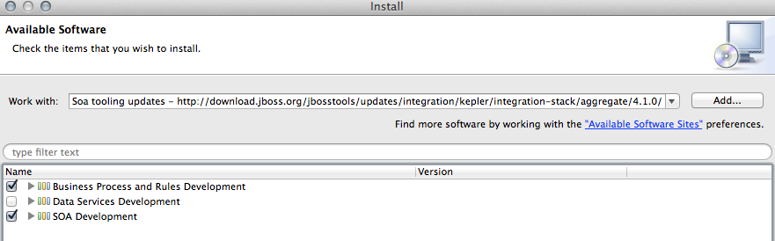
Detect and add a BRMS 5.3.1 runtime environment
- Select Preferences from the Window menu.
- In the left hand side, expand JBoss Tools and then select JBoss Tool Runtime Detection
- Select the Add button and navigate to the brms-rewards-demo/target folder, then select OK.
- The jboss-eap-6.1 runtime created earlier should have been found and selected. If so, select OK.
- Select OK again to close the Preferences dialog window.
Import Projects
- Select Import... from the File menu.
- Expand the Maven folder, and then select Existing Maven Projects.
- Select the Browse button to Select root directory, you should be in the brms-rewards-demo folder (if not, then navigate there) and then select OK.
- Make sure the project (brms-rewards-demo) is selected and then select Finish.
- The projects are now imported.

Start the JBoss Enterprise BRMS Platform
In this section, you will start the server from within JBoss Developer Studio.
- Select the Servers view
If it is currently not open, select Show View --> Other... from the Window menu and search for the Servers view.
- You should see the jboss-eap-6.1 server you created earlier.
- Right click on jboss-eap-6.1 and select Start from the pop-up menu. In a few moments your JBoss Enterprise BRMS Platform will be running.

Importing Project Repository into BRM
In this section, you will import all of the JBoss Enterprise BRMS artifacts into the Business Rules Manager.
- Open up your Web browser of choice and navigate to http://localhost:8080/jboss-brms/
- Use the default credentials of admin/admin
- Upon logging in, you will see the following prompt:
This looks like a brand new repository.
Would you like to install a sample repository?
Important: Please be sure to select No thanks.
- Select the Administration section on the left hand side
- From the Administration list select Import Export. This will open the Import Export window.
- Now select Browse... and navigate to brms-rewards-demo/support folder and select the repository_export.zip file.
- Lastly, select the Import button. Select OK to confirm that you want to import the artifacts.

Running the Demo

JBDS IDE demo
You can demo the project in the JBoss Developer Studio by making use of the editors, running the provided unit tests and watching the console for logged (verbose) output. The following will run the demo process with four unit tests:
- Select the file brms-rewards-demo/src/test/java/RewardsApprovalTest.java, right click, Run As..., JUnit Test.
Your output should look something like illustration 1 and example output of the console logging:
Executing work item WorkItem 2 [name=Log, state=0, processInstanceId=1, parameters{Message=Reward for erics: Outcome is Approved, Reason given is (Amazing demos for JBoss World!)., TaskName=Log}]

Executing work item WorkItem 3 [name=Email, state=0, processInstanceId=1, parameters{Body=Congratulations!, Subject=You received a reward!, To=erics@info.com, TaskName=Email, From=rewards@info.com}]

Executing work item WorkItem 2 [name=Log, state=0, processInstanceId=1, parameters{Message=Reward for erics: Outcome is Rejected, Reason given is (Amazing demos for JBoss World!)., TaskName=Log}]

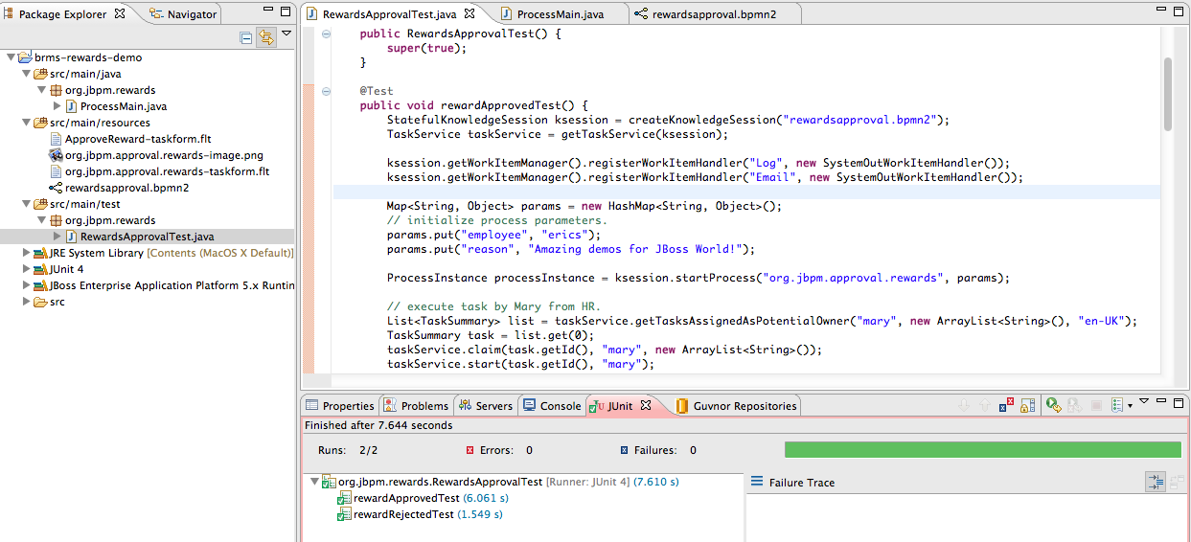Illustration 1: RewardsApprovalTest run.
The following will run the extended demo process with two unit tests:
- Select the file brms-rewards-demo/src/test/java/RewardsApprovalExtendedTest.java, right click, Run As..., JUnit Test.
Your output should look something like illustration 2 and example output of the console logging:
Executing work item WorkItem 2 [name=Log, state=0, processInstanceId=1, parameters{Message=Reward for erics: award is Approved, explanation is (Great work)., TaskName=Log}]

Executing work item WorkItem 3 [name=Log, state=0, processInstanceId=1, parameters{Message=Reward congrats for erics: Approved (Amazing demos for JBoss World!) added to personnel file., TaskName=Log}]

Executing work item WorkItem 4 [name=Email, state=0, processInstanceId=1, parameters{Body=Congratulations!, Subject=You received a reward!, To=erics@info.com, TaskName=Email, From=rewards@info.com}]

Executing work item WorkItem 2 [name=Log, state=0, processInstanceId=1, parameters{Message=Reward for erics: award is Rejected, explanation is (Too complicated for me)., TaskName=Log}]

Executing work item WorkItem 3 [name=Log, state=0, processInstanceId=1, parameters{Message=Rejected Reward for erics: Rejected (Amazing demos for JBoss World!) added to personnel file., TaskName=Log}]

Executing work item WorkItem 4 [name=Email, state=0, processInstanceId=1, parameters{Body=Bummer..., Subject=You're reward got rejected!, To=erics@info.com, TaskName=Email, From=rewards@info.com}]

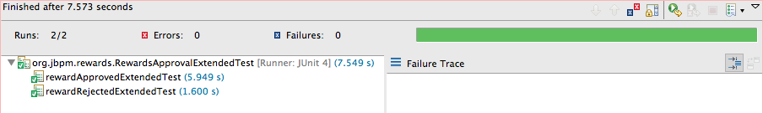Illustration 2: RewardsApprovalExtendedTest run.

ProcessMain
You can run the Rewards Demo (Extended) process from your IDE, tailoring your input objects as you see fit while leveraging the provided human task service in BRMS. You just need the JBoss BRMS server running to provide you with a human task service and follow these steps to demo the functionality:
- Start the JBoss BRMS server in JBDS via the Server tab.
- Select ProcessMain.java file or ProcessMainExtended.java file and right-click, Run As..., Java Application and watch the Console tab for output. This has started your process instance and it is waiting in the first human task.
- Go to browser and login to http://localhost:8080/business-central (erics, krisv, admin will all work).
- Open Task tab, select Group Tasks, Refresh, select entry that appears in list, hit Claim button, task will now disappear from list.
- Select Personal Tasks, Refresh, select entry listed, hit View button, fill in form and submit either as Rejected or Accepted as you desire.
- Return to JBDS Console tab and view logged process completion output based on path chosen (Accepted or Rejected).
Example output in the console when you start the process is blank, it is awaiting your attention at the first human task, after you complete the task you might see output as follows (based on Extended version with an Approved Reward):
Executing work item WorkItem 2 [name=Log, state=0, processInstanceId=1, parameters{Message=Reward for erics: award is Approved, explanation is (yep)., TaskName=Log}]

Executing work item WorkItem 3 [name=Log, state=0, processInstanceId=1, parameters{Message=Reward congrats for erics: Approved (Amazing demos for JBoss World) added to personnel file., TaskName=Log}]

Executing work item WorkItem 4 [name=Email, state=0, processInstanceId=1, parameters{Body=Congratulations!, Subject=You received a reward!, To=erics@info.com, TaskName=Email, From=rewards@info.com}]

BRMS BRM demo
The package was already imported so now we can look closer at web designers viewing, rules asset viewing, package building and deploying, web business central admin console viewing.

Web Designer
The BRM is available on http://localhost:8080/jboss-brms once the BRMS server has been fully started.
- Login with a user (admin, krisv, mary, john, erics available). To start fresh you can at any time import the original repository as follows: Administration → Import Export → Choose File ->brms-rewards-demo/support/repository-export.zip → Import (Ok to pop-ups)
- View process: Knowledge Bases → Packages → org.jbpm.rewards → Asset tab → view Processes and Open rewardsapproval or rewardsapprovalextended and wait for web designer to appear.

Build package for deployment
To build your package for deployment:
- Build package: Knowledge Bases → Packages → org.jbpm.rewards → Edit tab → Build Package button. Now the process has been deployed in the Business Central administration component.

Business Central
The Business Central administration console is available on http://localhost:8080/business-central once the BRMS server has been fully started and after deploying your process by building the package in BRMS BRM.
- Login as user (admin, erics, krisv have same rights).
- On left open Processes tab → Process Overview and you should see Rewards Approval v6 and Rewards Approval v1 appear. If not, hit Refresh. If not, ensure the demo package has been built without errors in BRM as described previously.
- Click on either Rewards Approval v6 or Rewards Approval v1 to select this process, then Start button and OK for pop-up.
- You will be presented with a form to fill in for starting this process, add an employee and reason before you hit the submit button. Close the window.
- Click on the running instance, then Diagram button which will pop up with illustration 4 showing the process started and waiting in the first human task node.
- You can view the Instance Data by hitting that button on the left.
- Change to Tasks tab on left, select Group Tasks, select task as it appears, hit Claim button. The task entry should disappear.
- Select Personal Tasks, the previous task will appear in your list, select it, push View button and fill in the Explanation field in the form and submit as Rejected or Approved. Close the window.
- Back to Processes tab, select Process Overview, hit Refresh and the instance that was listed as running should now disappear as it has completed.

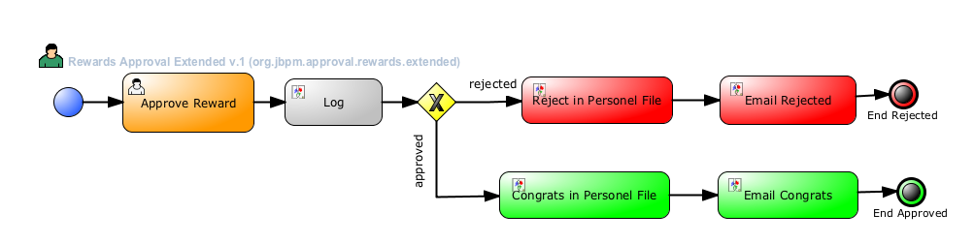Illustration 3: Diagram Rewards Approval Extended process in action.
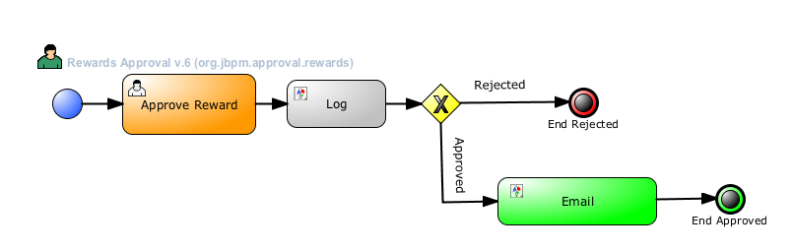Illustration 4: Diagram Rewards Approval process in action.

